Express JS

Express JS is a Framework for Node JS

**MERN Stack** = MongoDB, Express, React, Node

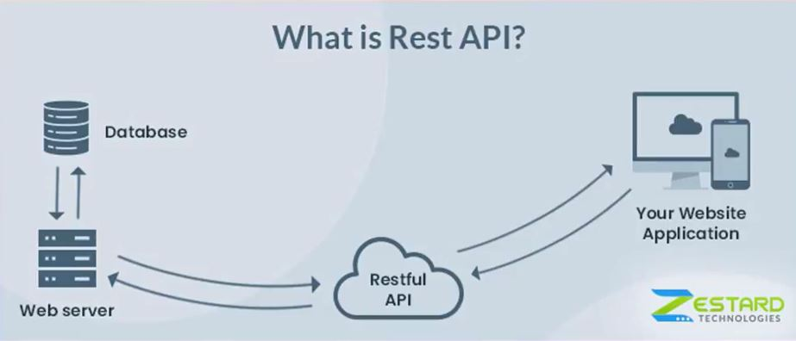

**Initial Setup**

Create a file: **index.js**

Add: npm init / npm init -y

Add: npm install express nodemon

File: **index.js**

const express = require('express');

const app = express();

const PORT = 3000;

app.get("/", (req, res) => {

    res.send(`Home Page`)

})

app.listen(PORT, (req, res) => {

    console.log(`Server is Running at http://localhost:${PORT}`)

})

File: **package.json**

  "scripts": {

    "test": "echo \"Error: no test specified\" && exit 1",

    "start": "nodemon index.js"

  },

Run: npm start

**Setup ENV**

Create a file at root directory: **.env**

Add: npm install dotenv

File: **index.js**

require('dotenv').config();

const PORT = process.env.PORT || 3000;

Create a file at root directory: **.gitignore**

File: **.gitignore**

node_modules/

.env

**Middleware**

Middleware is a function.

Src: <https://expressjs.com/en/guide/writing-middleware.html>

Create a Middleware function:

const myMiddleware = (req, res, next) => {

    console.log(`Middleware Function`);

    req.currentTime = new Date(Date.now())

    next();

}

Use Middleware:

app.get("/", myMiddleware, (req, res) => {

    console.log(`Home Page | ${req.currentTime}`)

    res.send(`Home Page `);

})

Everyone access:

app.use(myMiddleware)

app.get("/about", (req, res) => {

    console.log(`About | ${req.currentTime}`)

    res.send(`About Page`);

})

**Types of middleware**

Src: https://expressjs.com/en/guide/using-middleware.html

* 1. Application level
  2. Route level
  3. Error
  4. Built-in
  5. 3rd Party

**Static Middleware**

Create a folder at root: **public > image > about-us.png**

File: **index.js**

app.use(express.static('public'))

File: **index.html**

    <img src="./image/about-us.png" alt="image">